10.2 TMA SLOPE INDICATOR 1.4

Unfortunately, you cannot use TMA or any of its derivatives before some poster is going to yell, “REPAINT, REPAINT, REPAINT” It is like if you can say those words and you will bury the indicator to FOREX purgatory forever and ever. Whenever someone says these words I am going to refer them to this booklet so as not to fill our thread with pages of debate. The truth is this, you can either focus on the weaknesses of an indicator or you can focus on its strength. I am going to propose that the TMA slope indicator has a strength that could be valuable to a trader in a trade. There is a strength I think can be successfully used for our trading benefit: strength of the current currency move. In the following pages I hope to show how you can determine how long you should ride a trade or cut it short by using this indicator. So I will try my best to keep this short, simple, and easy to understand.

Below is a pic of the TMA indicator with its traditional settings. We can see how it would look so easy to trade.
The problem is we know from experience that these lines, line up long after price has gone. The lower the TF the more this problem will manifest itself. On a 4H chart it is less of a problem however, as you will see in the next two pics how much it can move around.

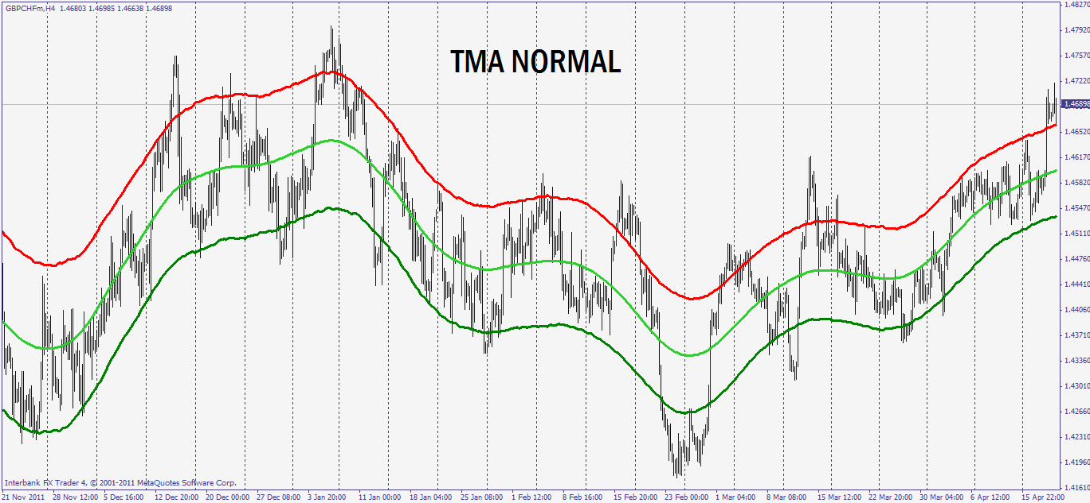

In this pic is a TMA true. What it does is it tries to keep the TMA lines where they are in real time. It doesn’t allow the TMA to readjust its lines later down the road. The TMA true with the traditional numbers looks like this.

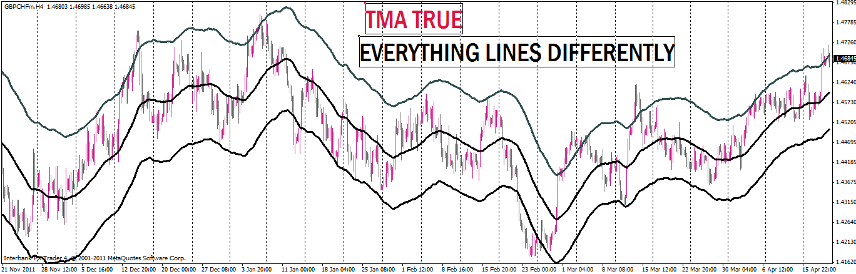

As you can see there is a difference but in a higher TF the difference is not as great as you may think. So this is how they look overlaid on each other.
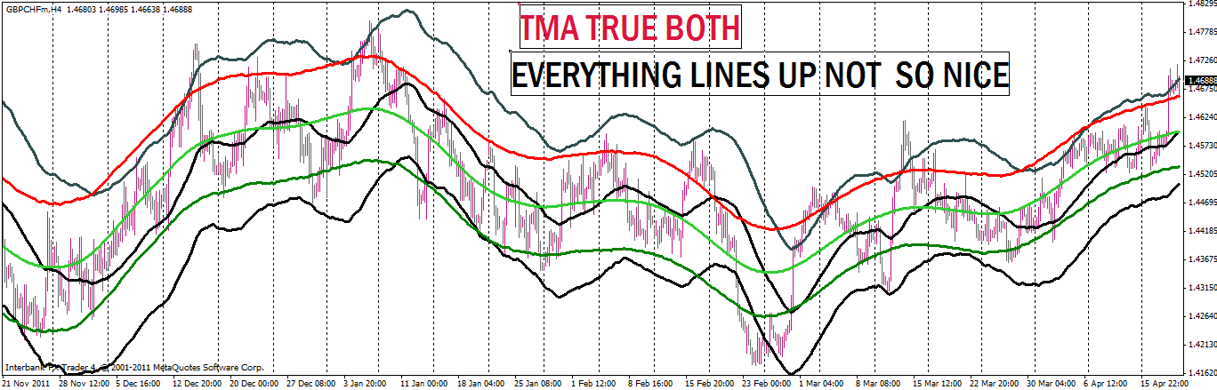

So I took the TMA TRUE and adjusted it so it would fit inside the TMA NORMAL after the TMA NORMAL had finished all its repainting and I got this.
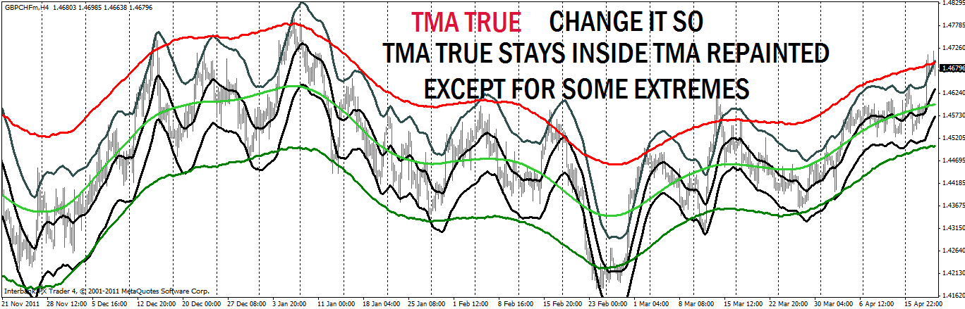

Now let us take the TMA slope indicator 1.4 and see what it normally would look like.
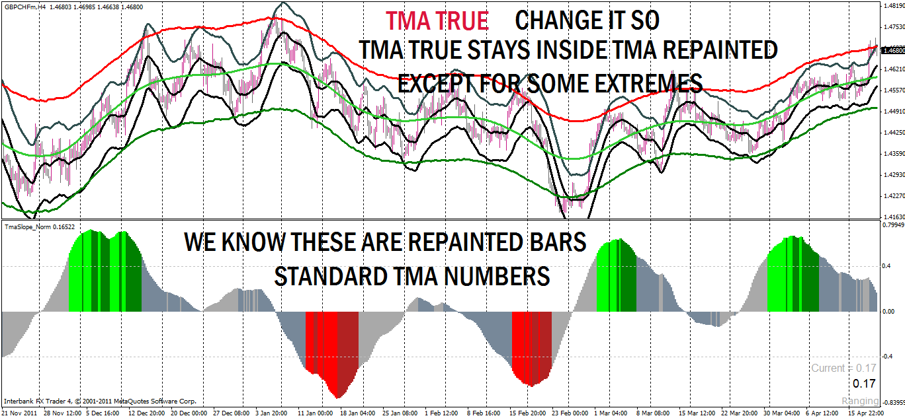

With these new numbers I now inserted them in the TMA slope indicator 1.4 so their numbers would match the TMA TRUE new numbers. This is what I got.
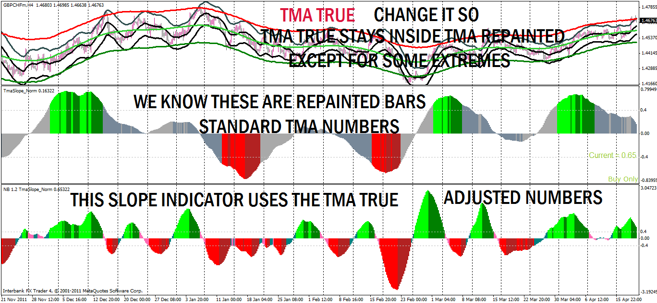

You can see the new SLOPE 1.4 reports changes in direction much more quickly than the original TMA slope indicator. But that is not all it can do. We can look at the size of the histogram and determine the strength of the move. This information helps us to decide whether to take profit or ride the trade out.
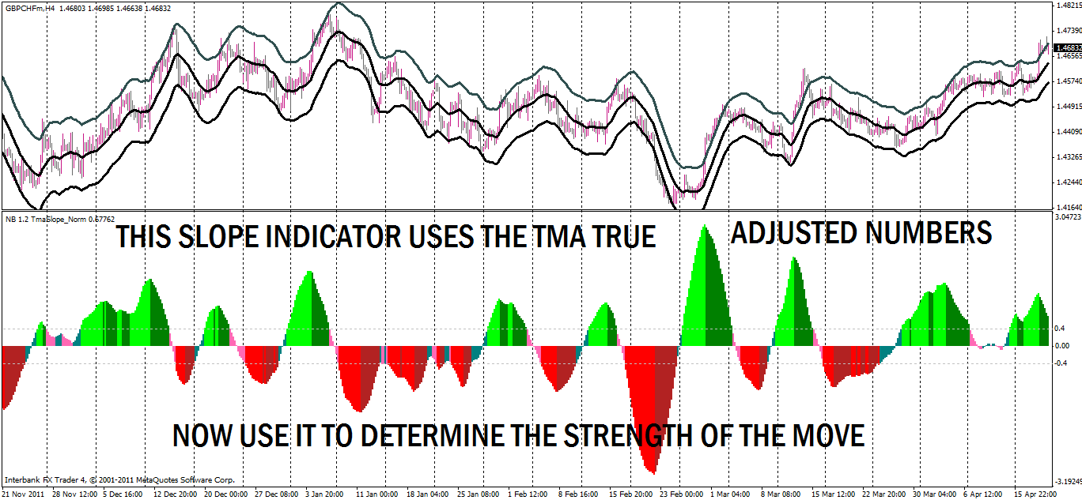

They say a picture is worth a thousand words so take a look at these numbers. We had strength lines at .4 -.4 and .8 and -.8, from these numbers we make decisions about our trades. They are the black lines on the indicator below.

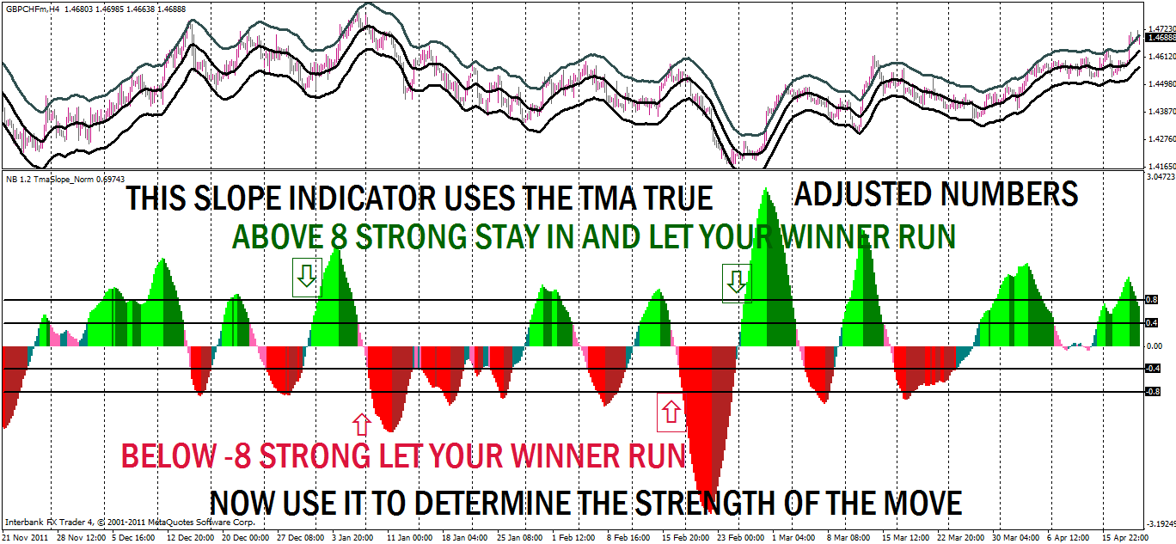
The next pic shows us when the histograms stay between the 8 and -8 price isn’t running so bank your profit and look for your next trade. See the pink area below.

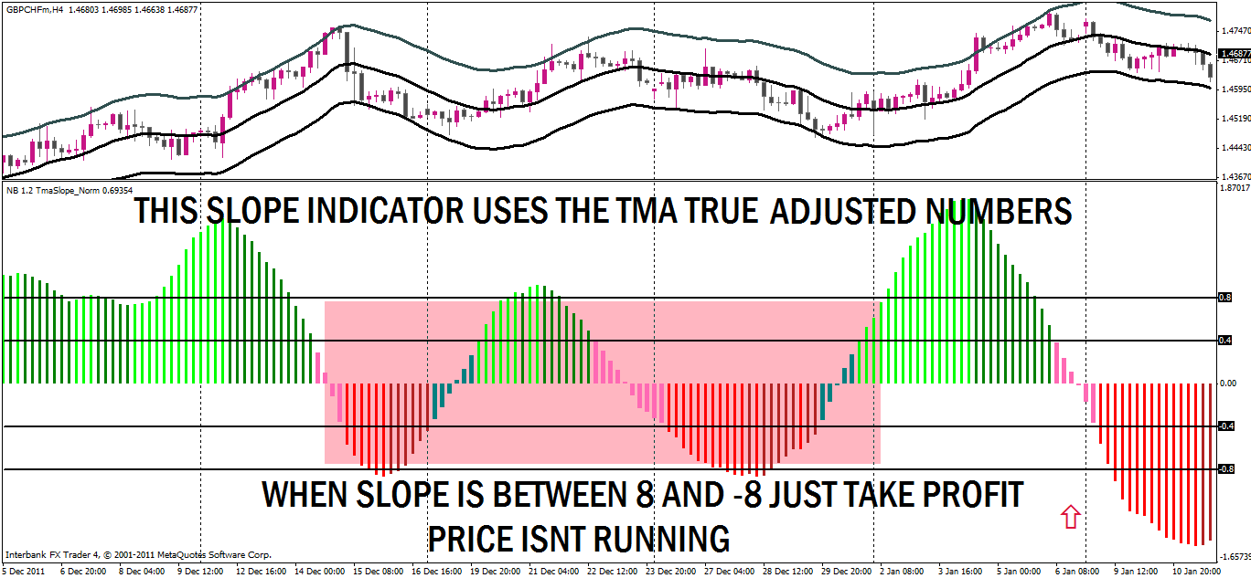

Also, it tells you price isn’t going anywhere so find something else to do and don’t try forcing a long term trade. You would be better off looking elsewhere or go scalping on a lower TF. See the pink area below.
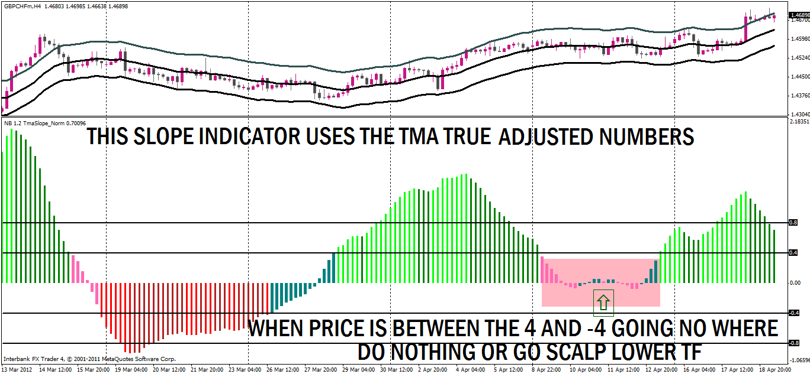

I listed the 5 main things we look for in using the TMA slope indicator with candles now at normal view. You can see maybe how it will help you. Combined with other indicators for entrances and exits you hope to have many successful trades but better yet to know when to fold em and when to let the winners run.
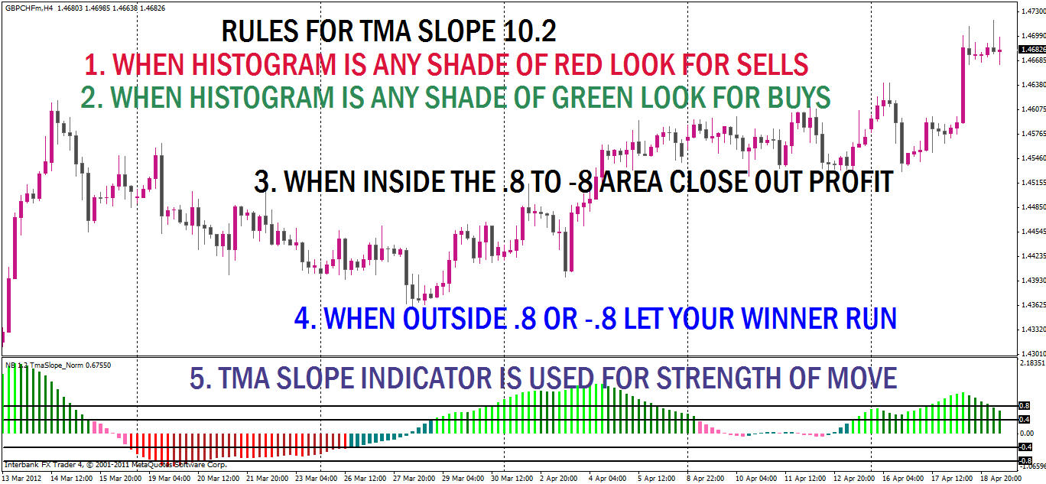

One last thing to notice about the TMA Slope indicator with these new figures used in the formula is its difference from other histogram indicators. I marked the center 0 line with a heavy green line in the pic below. When the histogram goes above that line that means the angle of the TMA center line is moving up. The greater the degree of angle the faster price is moving in that direction. If price goes above the 0.4 you have a very good chance that it will break the upper level of resistance for a breakout trade. Look for price to go up in a nice move. If you see price go below the -0.4 look for it to break resistance for a breakout trade. If you see the bars go above 0.8 then you have a very strong move that could break several R lines. If you see price go below -0.8 price action will probably break several S lines. When price hits its peak and the bars start coming back down, THAT IS NOT A SIGNAL TO REVERSE DIRECTION.!!!!
That is a signal that the rate of increase is decreasing not changing direction.
That is a signal that the upward curve is beginning to slow down not change direction. Some very good moves can still happen. So you can keep doing buys while it is above 0.4 and sells when it is below -0.4.
Again I repeat,
the sloping down of the indicator does not show price reversal;
it is only the slowing down of the upward climb of price action.

When the histogram bars are between the 0.4 and -0.4. Then it is showing that price is ranging and you can look to close your buy/sell trades. If the bars are above the 0 line but less than 0.4 the upward moves will be a bit stronger than the lower moves. If the bars are below the 0 line but greater than -0.4 then the downward moves will be stronger in the range period. As the bars approach back to the .4 lines in either direction then start looking for a break out trade.
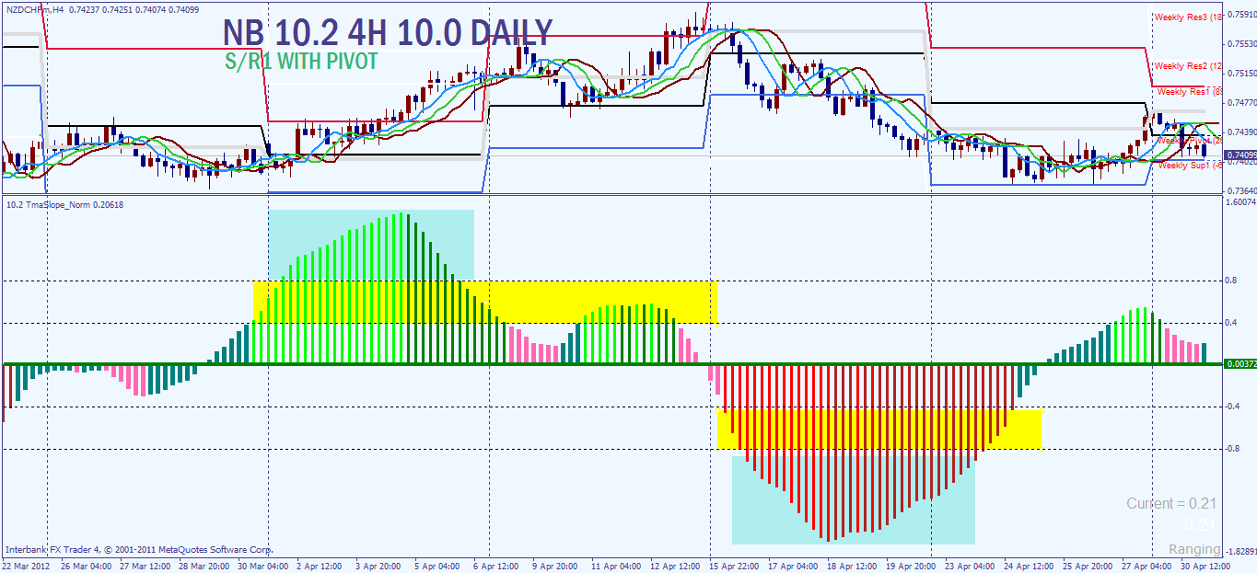

So my final comments are these:
1. We are going to use this indicator for its one really good strength and that is determining the present strength of the currency move. The direction and angle of the slope is what we use this for. The greater the angle of the slope, the bigger the move, the bigger the histogram bars.
2. I have adapted these numbers to the 4H chart and the daily chart. I have not tested it very much on other TF. There will be some repainting but it is minimized at the higher TF and by the quicker response numbers used instead of the original default numbers. In other words we have cut the repainting issue to its minimum and will use the TMA Slope strength to its maximum.
3. Letting your winners run and reentering with extra positions on a run will now become doable, or at least put the odds in your corner that you can become successful in the attempt. When price moves above/below that .8 line, look to run multiple positions with the trend.
4. If you are a multiple level trader, recovery trader, martingale trader, and you see price go above that 0.8 or below -0.8 you know you are in trouble and are in for the long haul.

Thank you,

Nanningbob
May 1, 2012

